Inline Functions
Write a program to make an inline function
Rudra Chinhara
CODE
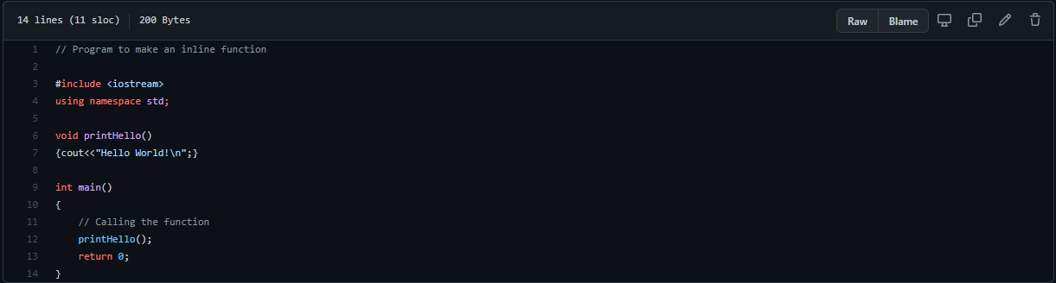
OUTPUT

GitHub Link

